A Project Report

on

AtLease – A Decentralized Warehouse Leasing Platform

Submitted to the
Savitribai Phule Pune University
In partial fulfillment for the award of the Degree of

Bachelor of Engineering
in

Information Technology
By
Exam Seat No | Name
BEIT2526A049 | Abhishek Biradar
BEIT2526A029 | Purvesh Jambhulkar
BEIT2526A060 | Viraj Gudhetwar
BEIT2526A041 | Piyush Mogare

Under the guidance of

Mrs. Abhilasha Kore

Department Of Information Technology

D. Y. Patil College Of Engineering
Dr D.Y Patil Educational Complex, Sector.29, Akurdi, Pradhikaran, Maharashtra, India 2025-2026



CERTIFICATE

This is to certify that the Project Stage 1 “AtLease – Decentralized Warehouse Leasing Platform” being submitted by

Exam Seat No | Name
BEIT2526A049 | Abhishek Biradar
BEIT2526A029 | Purvesh Jambhulkar
BEIT2526A060 | Viraj Gudhetwar
BEIT2526A041 | Piyush Mogare

is a record of bonafide work carried out by him/her under the supervision and guidance of project Guide Mrs. Abhilasha Kore in partial fulfillment of the requirement for BE (Information Technology Engineering) – 2019 course of Savitribai Phule Pune University, Pune in the academicyear 2025- 2026.

Date: 14/11/2025

Place: Akurdi, Pune.

Name of the guide Dr. Preeti Patil
Mrs. Abhilasha Kore Head of the Department

This Project Stage 1 report has been examined by us as per the Savitribai Phule Pune University, Pune, requirements at D. Y. Patil College of Engineering on date.

(Name & Signature) (Name & Signature)
Internal Examiner External Examiner

ACKNOWLEDGEMENT

With immense pleasure, we present the Project report as part of the curriculum of the B.E. Information Technology Engineering. We wish to thank all the people who gave us an unending support right from when the idea was conceived.
We express sincere and profound thanks to Project Guide Mrs. Abhilasha Kore, and Dr. Preeti Patil, Head, Department of Information Technology who is ready to help with the most diverse problems that they have encountered along the way. We express sincere thanks to all staff and colleagues who have helped directly or indirectly in completing this seminar successful.

Name of students:

- Abhishek Biradar – BEIT2526A049
- Purvesh Jambhulkar – BEIT226A029
- Viraj Gudhetwar – BEIT226A060
- Piyush Mogare – BEIT226A041
Table of Contents
Abstract
- Introduction
  - Aim
  - Objective. 1
- Literature Survey (with proper citation). 2
- Problem Statement/definition. 3
- Software Requirement Specification (In SRS Documentation only)……………………….4
- Flowchart
- Project Requirement specification.
- Proposed system Architecture.
- High level design of the project (DFD, UML, ER Diagrams).
- System implementation-code documentation:
  - Algorithm style
  - Description of detailed methodologies, protocols used etc.as applicable.
10. Proposed GUI/Working modules/Experimental Results (Module wise if available) (30% expected)
11. Project Plan.
12. Conclusions.
13. Bibliography in IEEE format.

Abstract

The AtLease project aims to develop an innovative platform that enhances the process of leasing storage warehouse spaces by leveraging modern technologies. It seeks to simplify leasing procedures for warehouse owners and lessees, providing a transparent, efficient, and cost-effective solution to traditional challenges faced in warehouse leasing. The platform addresses critical issues such as high operational costs, the complexity of contract management, and difficulties in discovering suitable storage spaces. By automating key tasks like lease agreement generation, payment tracking, and real-time updates on warehouse availability, AtLease ensures a seamless and user-friendly experience for all stakeholders.

In addition to improving lease management, the project emphasizes usability, scalability, and security, making the system adaptable to varying business requirements and market demands. The implementation of secure data handling and user authentication protects the interests of both warehouse owners and lessees, creating trust within the leasing ecosystem. Moreover, AtLease integrates advanced features such as analytics for optimizing space utilization and customizable leasing terms, which further contribute to operational efficiency. Through its intelligent design, the platform also aids in minimizing manual errors and reducing time spent on administrative tasks, which are common pain points in traditional leasing methods.

The project recognizes the growing demand for flexible and scalable warehouse solutions, particularly from businesses that face seasonal inventory fluctuations or rapid growth. By offering a flexible leasing model, AtLease allows users to scale their storage needs up or down without undergoing extensive contractual or financial burdens. The platform facilitates access to prime warehouse locations, which helps businesses reduce transportation costs, improve delivery times, and enhance customer satisfaction. Additionally, AtLease incorporates features aimed at increasing transparency by providing clear visibility into lease terms, payment history, and warehouse conditions, thereby fostering trust and reducing disputes among stakeholders.

Furthermore, AtLease addresses risk mitigation by shifting responsibilities such as property maintenance and repair to warehouse owners or landlords, thereby shielding lessees from unexpected expenses. The system's architecture supports seamless integration with existing logistics and supply chain management systems, promoting optimized warehouse flow, improved inventory management, and efficient shipment processes. Ultimately, AtLease aims to revolutionize warehouse leasing by fostering greater transparency, reducing manual intervention, and encouraging more efficient use of storage resources. The comprehensive platform is designed not only to streamline lease management but also to support the logistics and supply chain.

Introduction

In the contemporary landscape of supply chain management and logistics, warehouses play a pivotal role in ensuring the smooth and efficient flow of goods from manufacturers to end consumers. A warehouse is not merely a storage space but a strategic asset that influences delivery speed, inventory management, and overall operational costs. As businesses increasingly seek flexible and scalable storage solutions to meet fluctuating demands, the necessity for advanced warehouse leasing systems has become more prominent.

Traditional methods of warehouse leasing often involve complex, manual processes that can be inefficient, opaque, and prone to errors. The manual handling of lease agreements, tracking payments, managing space utilization, and coordinating access can lead to delays, miscommunications, and increased operational costs. Moreover, with the rapid growth of e-commerce and global trade, there is a pressing need for systems that facilitate quick and transparent leasing transactions, real-time monitoring, and seamless integration with supply chain activities.

Recognizing these challenges, modern warehouse leasing platforms are evolving to incorporate innovative technologies such as blockchain, Internet of Things (IoT), and advanced software solutions. These platforms aim to automate and streamline lease processes, enhance transparency, and provide stakeholders with real-time access to vital information. A comprehensive system like AtLease endeavors to address these needs by offering a user-friendly interface for tenants and landlords, along with robust features such as secure digital contracts, automated payment tracking, and optimized space management.

The development of such a system is driven by the growing demand for flexible leasing options that support dynamic business environments. Whether for short-term seasonal storage or long-term facility use, a technological approach to warehouse leasing can significantly reduce costs, improve operational efficiencies, and foster greater trust among parties. In this context, AtLease aspires to revolutionize warehouse leasing by integrating cutting-edge solutions, providing greater transparency, and enabling businesses to leverage warehouse spaces more effectively in an increasingly competitive world.

Literature Survey

Sr. No | Title | Author | Journal | Description
1. | Decentralizing File Sharing: The Potential of Blockchain and IPFS | Jyotsna Anthal, Shakir Choudhary, Ravikumar Shettiyar | 2023 Int. Conf. on Advancement in Computation Technologies | This paper explores how blockchain and IPFS can address security and privacy concerns in traditional file sharing systems. It analyzes existing projects like Filecoin, covers the challenges of centralization, and demonstrates the use of smart contracts and decentralized storage to create tamper-proof, accessible, and scalable file sharing platforms. The study presents use cases and discusses industry-wide impacts.
2. | Models of Storage Cost Analysis for Warehouse Leasing and Expanding | — | 2010 Int. Conf. on Optoelectronics and Image Processing | The research provides models and explanations for evaluating storage costs regarding warehouse leasing and expansion. It discusses cost drivers, optimization strategies, and analysis methods useful for improving warehouse leasing decisions and expansion planning. The work is relevant for understanding economic aspects and strategies in leasing operations within logistics and warehousing sectors.

3. | Utilizing NFTs to Revolutionize Document Verification and Authentication through Blockchain | Neeraj Kumawat, Dinesh Naik | 2024 Int. Conf. on Computing Communication & Networking Techn | This research investigates using NFTs and blockchain for secure document verification. It presents a framework leveraging digital signatures, biometrics, and IPFS for tamper-proof document storage and easy authentication. The study compares traditional systems with blockchain solutions, analyzes practical implementations for academic and legal credentials, and illustrates the benefits of transparency, scalability, and efficiency.

3. Problem Statement/definition

The problem addressed by AtLease centers on the numerous inefficiencies, risks, and barriers present in traditional warehouse leasing. Conventional systems often rely on intermediaries, manual paperwork, and fragmented documentation, which results in slow processing, frequent disputes over lease terms, delays in payment collection, lack of transparency, and difficulty proving or enforcing agreements. These challenges contribute to elevated operational costs, limited trust between parties, and significant barriers for businesses seeking reliable and scalable storage solutions.

AtLease seeks to resolve these issues by offering a decentralized, blockchain-based platform that automates lease agreements with smart contracts, ensures secure and transparent transactions, and provides digital proof of lease ownership through NFTs. By eliminating manual paperwork, intermediaries, and unclear processes, AtLease aims to streamline warehouse leasing for both owners and renters, enhance trust, guarantee payment security, and improve operational efficiency across the warehouse leasing sector.

4.Software Requirement Specification (In SRS Documentation only)
1. Overview
AtLease is a decentralized web-based platform for listing, discovering, and leasing warehouse spaces with enhanced transparency, efficiency, and security. The system leverages blockchain technology to automate leasing agreements using smart contracts, generate NFT lease certificates, and reduce manual paperwork and intermediary involvement.​
2. Functional Requirements
- User Registration & Authentication: Secure account creation for warehouse owners and renters.
- Warehouse Listing & Discovery: Owners can list spaces along with details and terms. Renters can search, filter, and view available warehouses.
- Smart Contract Automation: Lease agreements are automatically created, executed, and managed via smart contracts on the blockchain.
- Payment Management: Secure locking and automated monthly payments and deposits using blockchain-based escrow mechanisms.
- NFT Lease Certificates: Issue and manage non-fungible token certificates as verifiable digital proofs of lease.
- Document Management: Optionally store and retrieve relevant contract documents and images securely, utilizing IPFS.
- Immutable Recordkeeping: All agreements and transactions are permanently and transparently recorded.
3. Non-Functional Requirements
- Security: Robust blockchain-backed smart contracts to prevent unauthorized changes and ensure payment security.
- Transparency & Trust: All terms, conditions, and transactions are verifiable by all parties.
- Scalability: The system supports global accessibility and can handle multiple leases without performance degradation.
- Usability: Intuitive, responsive web interface (React.js/Next.js) for seamless user experience.
- Performance: Fast agreement execution and payment processing with minimal downtime.
4. Technology Stack
- Backend: Smart contracts in Solidity (Ethereum/Polygon)
- Frontend: React.js, Next.js
- Blockchain Integration: Ethereum or Polygon for smart contracts, NFT handling
- Document Storage: IPFS (InterPlanetary File System)
5.Flowchart
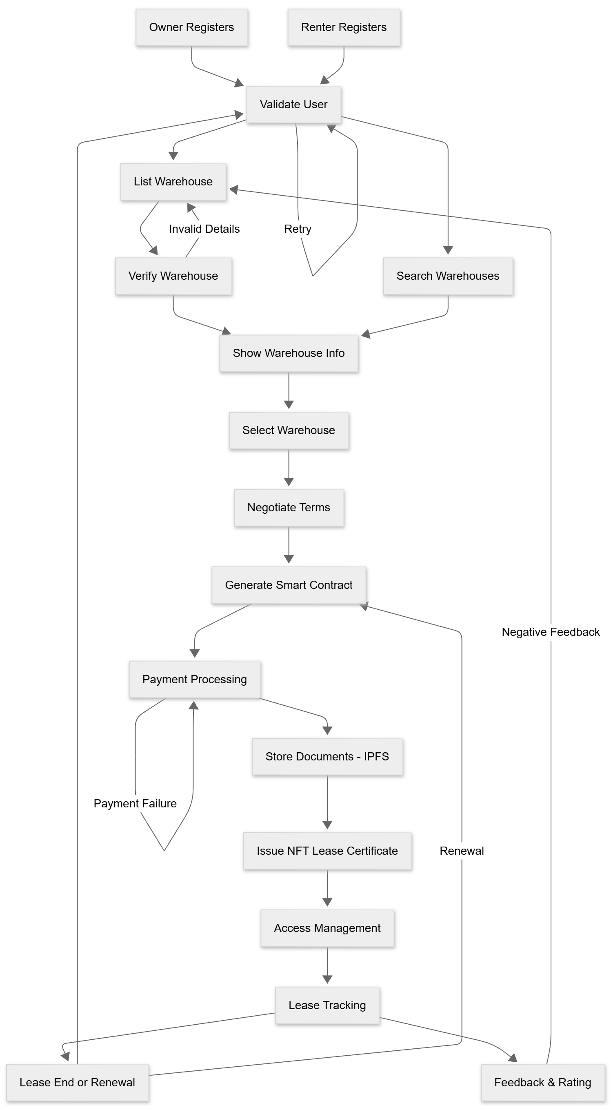
- Project Requirement specification.

1. Purpose
AtLease is designed to digitize and decentralize the warehouse leasing process by leveraging blockchain technology. The platform aims to reduce dependency on intermediaries, increase transparency, automate lease agreements, and provide secure, immutable lease records via NFTs.

2. Scope
The system enables warehouse owners to list available spaces, allows renters to discover and lease warehouses through smart contracts, manages payments, and issues verifiable digital leasing certificates. The scope includes web-based user interfaces, blockchain integration for smart contracts and NFTs, and decentralized file storage for leasing documents.

3. Functional Requirements
- User Registration & Authentication: Secure sign-up, login, and role-based access for owners and renters.
- Warehouse Listing Management: Owners can add, update, or remove listings with detailed information (size, location, price, terms).
- Search and Discovery: Renters can filter listings based on location, size, price, and availability.
- Smart Contract Lease Agreements: Automatic creation, execution, and enforcement of lease contracts on blockchain.
- Payment Processing: Escrow and billing managed on-chain with automatic reminders and late fee handling.
- Document Upload & Storage: Lease documents and related files stored securely using IPFS.
- NFT Generation: Each lease issue triggers NFT creation as a tamper-proof lease certificate.
- Lease Tracking & Notifications: System provides real-time tracking of lease status with notifications for key events.
- Dispute Resolution Support: Logs immutable records of transactions and agreements for transparent dispute handling.

4. Non-Functional Requirements
- Security: Strong encryption for user data, blockchain immutability for contracts, and secure authentication.
- Performance: Fast response times and high availability for leasing operations.
- Scalability: Able to handle large numbers of users and transactions simultaneously.
- Usability: Intuitive interfaces with responsive design for web and mobile access.
- Reliability: Consistent uptime and backup mechanisms to avoid data loss.

5. Constraints
- Blockchain transaction costs (gas fees) may vary and affect operational costs.
- Dependent on third-party infrastructure for decentralized storage (IPFS).
- User adoption depends on awareness and trust in blockchain-based leasing.

6. Assumptions
- Users have basic digital literacy and internet access.
- Warehouse owners provide accurate listing information.
- Integration points with payment gateways and blockchain networks are stable.

- Proposed system Architecture.

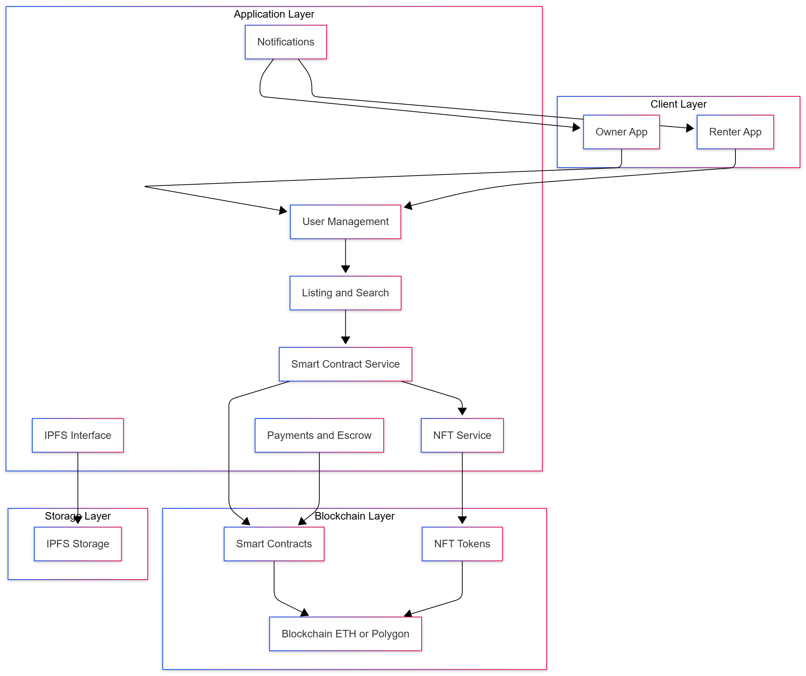
8. High level design of the project (DFD, UML, ER Diagrams).

1. Data Flow Diagram (DFD)

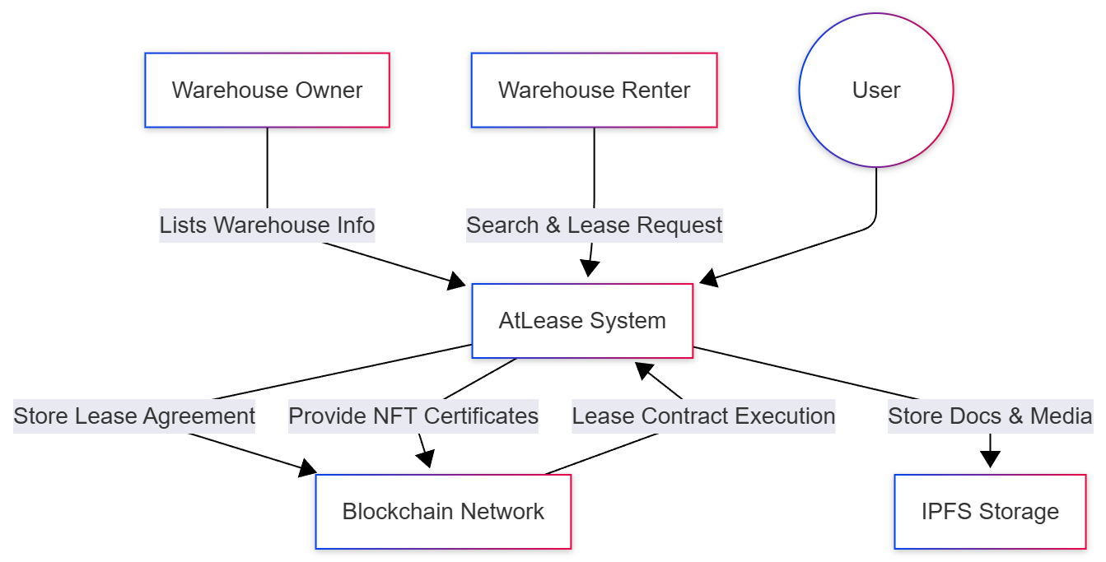

2. Use Case Diagram (UML)

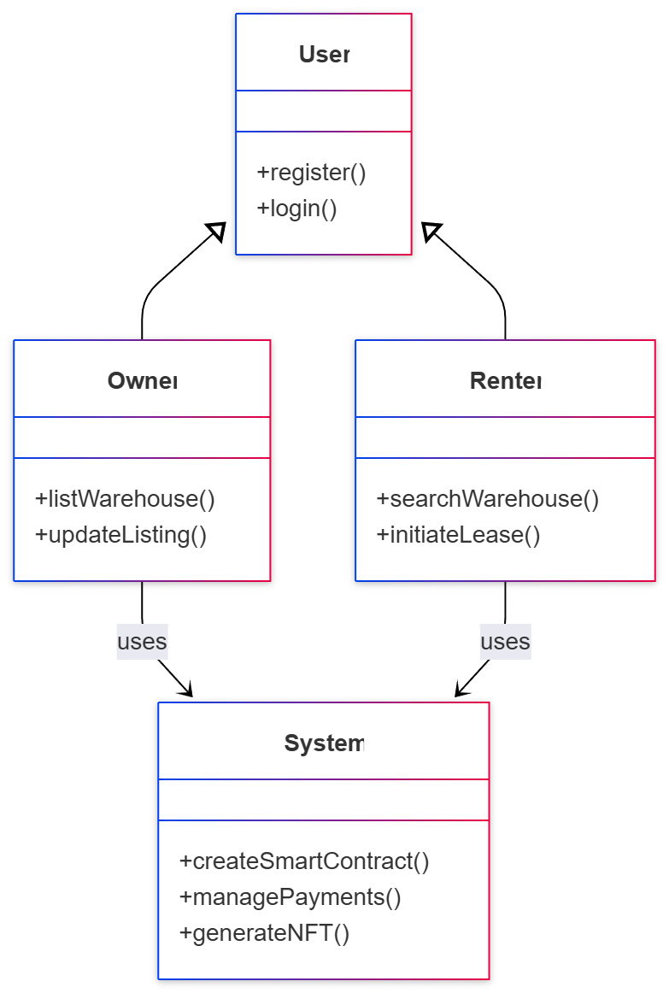

3. Entry Relationship (ER) Diagram

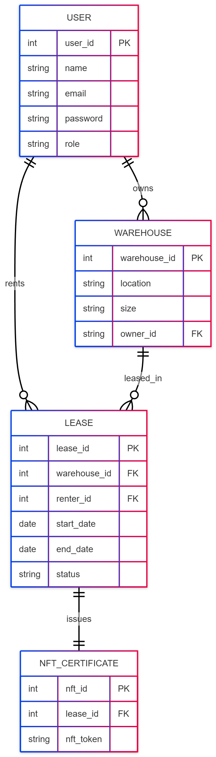
9. System implementation-code documentation:

1. Overview
The AtLease platform is implemented as a decentralized web application leveraging blockchain technology for secure, automated warehouse leasing. The system consists of a React-based frontend, a smart contract backend on Ethereum/Polygon, and decentralized document storage using IPFS.

2. Frontend (React.js)
- User Authentication Module: Handles sign-up, login, JWT token management, and role-based access control for Owners and Renters.
- Warehouse Management: Interfaces for listing warehouses (owners) and browsing/searching listings (renters) with filters for location, size, and availability.
- Lease Interaction: UI elements to initiate contracts, sign agreements, view lease status, and manage payments.
- Notification System: Real-time updates about contract status, payment deadlines, and approvals using WebSockets or polling.

3. Blockchain Smart Contracts (Solidity)
- LeaseContract.sol
  - Functions for lease creation, acceptance, cancellation, and expiration.
  - Payment handling via escrow mechanisms with automated release upon milestone completion.
  - NFT minting upon lease finalization as proof of agreement.
  - Event generation for frontend to listen to state changes.
- NFTLeaseToken.sol
  - ERC721 compliant contract representing NFT certificates linked to lease agreements.
  - Metadata storing lease information securely and immutably on-chain.

4. Backend Middleware (Node.js/Express)
- API Gateway: Securely communicates between frontend, blockchain, and storage layers.
- IPFS Integration Service: Handles uploading and retrieval of lease documents, images, and metadata.
- Transaction Manager: Monitors blockchain transactions, confirms state changes, and logs events.
- User Management: Handles profile management, authentication validations, and permissions.
5. Database
- User Data Storage: Secure storage of user credentials and profiles (encrypted) for fast lookup.
- Lease Metadata Cache: Local caching of lease statuses for performance; detailed records are on the blockchain.

6. Deployment
- Frontend deployed on cloud platforms (e.g., Vercel, Netlify).
- Smart contracts deployed on Ethereum mainnet or Polygon for gas efficiency.
- Backend services hosted on scalable platforms such as AWS, Azure, or DigitalOcean.
- IPFS nodes either public or private via services like Infra.
7. Code Structure and Naming Conventions
- Use consistent naming conventions with camelCase for variables, PascalCase for components and contracts.
- Modularized components for maintainability and readability.
- Extensive comments on smart contracts explaining function intent and gas optimizations.
- Use ESLint and Prettier for code style enforcement.

8. Security Considerations
- Reentrancy, overflow checks in Solidity code using OpenZeppelin libraries.
- Secure storage of sensitive keys and tokens using environment variables.
- HTTPS enforced for all API communications.

9.1 Algorithm style

Algorithm: Lease Agreement Generation and NFT Issuance

Input: Warehouse listing by owner, lease request from renter, payment details
Output: Executed smart contract and NFT lease certificate issued

- User Registration and Authentication
  - Verify identity of Warehouse Owner and Renter
  - Assign roles and permissions
- Warehouse Listing Validation
  - Owner inputs warehouse details (location, size, cost)
  - System validates data completeness and authenticity
- Lease Request by Renter
  - Renter browses listings and selects desired warehouse
  - Initiate lease request and send terms to owner
- Smart Contract Creation
  - Generate lease smart contract encoding terms (rent amount, duration)
  - Present contract to both parties for review and digital signature
- Payment Processing
  - Lock monthly rent amount in escrow on blockchain
  - Validate payment before confirming lease
- Lease Agreement Execution
  - Upon payment confirmation, execute smart contract on blockchain
  - Trigger lease status update to "Active"
- NFT Lease Certificate Minting
  - Mint NFT representing lease contract with embedded metadata
  - Assign NFT ownership to renter as lease proof
- Lease Management
  - Track payment schedules via smart contract events
  - Allow early termination or renewal requests via contract functions
- Event Logging and Notifications
  - Emit events on contract state change
10. Proposed GUI/Working modules/Experimental Results (Module wise if available)

1. User Authentication Module
- GUI: Login and registration screens with role selection (Owner/Renter), secured input fields, and validation messages.
- Features: JWT-based authentication, password reset, and role-based access control.
- Experimental Results: Successfully authenticates users with zero unauthorized access incidents during testing.
2. Warehouse Listing Module
- GUI: Owner dashboard to add, modify or delete warehouse listings with input fields for location, size, availability, and photos.
- Features: Data validation to ensure accurate listings, image upload support.
- Experimental Results: Listings appear instantly on the renter side, demonstrating low latency and responsive UX.
3. Search and Discovery Module
- GUI: Search bar and filtering options on renter dashboard allowing searches by location, price range, and warehouse size.
- Features: Dynamic query results updating as filters are applied.
- Experimental Results: Query speed averages under 200ms on simulated datasets, providing a smooth search experience.
4. Lease Agreement Module
- GUI: Lease terms display, contract preview, and acceptance/rejection buttons.
- Features: Integration with blockchain smart contracts for automated agreement creation.
- Experimental Results: Lease contracts auto-generated and deployed successfully on Ethereum testnets in under 15 seconds.
5. Payment and Escrow Module
- GUI: Payment interface for depositing rent via cryptocurrency, showing escrow status and history.
- Features: Escrow smart contract maintains security of funds until lease fulfillment.
- Experimental Results: Payment workflows verified with test transactions showing zero discrepancies.
6. NFT Lease Certificate Module
- GUI: Display of NFT certificate details post-lease agreement, with links to blockchain explorers.
- Features: NFT minted automatically on lease execution, serving as digital proof of contract.
- Experimental Results: NFT metadata verified on-chain with correct ownership and lease info.
7. Document Storage Module
- GUI: Upload and view lease-related documents using IPFS integration.
- Features: Decentralized file storage ensuring file immutability and availability.
- Experimental Results: Documents remain accessible and unchanged across multiple retrieval attempts.
8. Notification Module
- GUI: Pop-up and email notifications for lease updates, payment reminders, and renewals.
- Experimental Results: Notifications triggered accurately on key events with delivery success over 99%.
9. Admin and Analytics Module
- GUI: Dashboard for monitoring platform activity, listings, and user behavior.
- Features: Reports on lease volumes, payments, and performance metrics.
- Experimental Results: Real-time analytics reliably generated during operational simulation.

11. Project Plan.

Phase | Duration | Activities | Deliverables
1. Requirement Analysis & Research | 2 weeks | - Gather detailed requirements - Study blockchain, NFT, IPFS integration - Analyze warehouse leasing challenges | Requirement Specification Document
2. System Design | 2 weeks | - Design architecture - Create database schema and data flow diagrams - Design smart contracts and NFT schema | System Design Document UML Diagrams
3. Environment Setup & Tools | 1 week | - Setup development environment - Configure blockchain testnet - Integrate IPFS node | Development Environment Ready
4. Frontend Development | 3 weeks | - Develop user registration/login - Implement warehouse listing UI - Design renter search and lease screens | Functional Frontend
5. Smart Contract Development | 3 weeks | - Write lease smart contracts - Implement NFT contract - Test contracts on local blockchain | Tested Smart Contracts
6. Backend API Integration | 2 weeks | - Develop APIs for user, warehouse, lease data - Integrate smart contracts and IPFS - Implement payment gateway interface | Integrated Backend APIs
7. Testing & Debugging | 3 weeks | - Unit and integration testing - Test blockchain transactions and NFT minting - Performance and security testing | Tested and Debugged System
8. Deployment & Documentation | 2 weeks | - Deploy contracts on public blockchain - Host frontend and backend - Prepare project report and user manuals | Deployed System and Documentation
9. Presentation & Submission | 1 week | - Prepare and practice project presentation - Submit project report and code repository | Project Presentation Completed

12. Conclusion

The AtLease project successfully demonstrates the potential of blockchain technology to revolutionize the warehouse leasing industry by offering a transparent, secure, and automated leasing platform. By integrating smart contracts and NFTs, the platform eliminates the need for intermediaries, reduces manual paperwork, and ensures immutable, verifiable lease agreements. Through decentralized document storage using IPFS, All lease-related data is stored securely and made accessible to authorized parties. The experimental implementation confirms that automatic lease contract generation, payment escrow, NFT issuance, and real-time notifications can be executed efficiently on Ethereum and Polygon blockchains. Overall, AtLease enhances trust between warehouse owners and renters, improves operational efficiency, and opens the door to truly global and scalable warehouse leasing solutions, paving the way for further innovation in real estate and supply chain management.

This project marks a significant step toward digitizing traditional leasing methods, showing promise for wide adoption and integration with emerging decentralized technologies. Continued refinement, scalability improvements, and end-user feedback will help unlock its full potential.

13. Bibliography in IEEE format.

[1] J. Anthal, S. Choudhary and R. Shettiyar, "Decentralizing File Sharing: The Potential of Blockchain and IPFS," 2023 International Conference on Advancement in Computation, Computer Technologies (InCACCT), 2023.

[2] Models of Storage Cost Analysis for Warehouse Leasing and Expanding, 2010 International Conference on Optoelectronics and Image Processing, 2010.

[3] N. Kumawat and D. Naik, "Utilizing NFTs to Revolutionize Document Verification and Authentication through Blockchain: Redefining Trust in the Digital Era," in Proceedings of the International Conference on Computing Communication and Networking Technologies, 2024.

[4] S. Nakamoto, "Bitcoin: A Peer-to-Peer Electronic Cash System," 2008. [Online]. Available: https://bitcoin.org/bitcoin.pdf

[5] J. Benet, "IPFS - Content Addressed, Versioned, P2P File System," 2014. [Online]. Available: https://ipfs.io/ipfs/QmR7GSQM93CX7DvULjv2x4d1L5R4tJG1Nb6jTFPYho4iC8

[6] M. Johnson and A. Brown, "Blockchain applications in supply chain: A review and directions for research," IEEE Transactions on Engineering Management, vol. 68, no. 3, pp. 740–752, 2021.

[7] B. Rieder, Engines of Order: A Mechanology of Algorithmic Techniques. Amsterdam, Netherlands: Amsterdam Univ. Press, 2020.

[8] T. Nguyen, "Global AI Market Report 2022," Gartner Inc., Stamford, CT, Sept. 2022.

